SYNOPSIS

Report on

IMAGE MODIFIER

by

Akanksha Mangal
2200290140015
Session:2023-2024 (III Semester)

Under the supervision of
Ms. Divya Singhal
KIET Group of Institutions, Delhi-NCR, Ghaziabad



DEPARTMENT OF COMPUTER APPLICATIONS
KIET GROUP OF INSTITUTIONS, DELHI-NCR,
GHAZIABAD-201206
(2022 - 2023)

ABSTRACT

In today's digital age, image editing has become an integral part of various industries, including photography, graphic design, and social media. This abstract presents an innovative Java-based image editing system designed to provide users with a versatile and user-friendly platform for enhancing and manipulating digital images. This system leverages the power of Java's object-oriented programming capabilities to offer a wide range of image editing functionalities, making it a valuable tool for both amateur and professional users.

The Java-based image editing system comprises a robust set of features, including image import/export, basic editing tools (such as cropping, resizing, and rotation), advanced filters and effects (such as blurring, sharpening, and color correction), and text overlay capabilities. The system's intuitive user interface ensures ease of navigation and accessibility for users of all levels of expertise. Additionally, it supports a variety of popular image file formats, ensuring compatibility with various image sources.

TABLE OF CONTENTS

Page Number
1. Introduction --
2. Literature Review --
3. Project / Research Objective --
4. Project Flow/ Research Methodology--
5. Project / Research Outcome --
6. Proposed Time Duration --
References/ Bibliography
--

1. INTRODUCTION

Our project topic is “IMAGE PROCESSING TECHNIQUES”. It is a desktop based application. This project aims at creating various effects for processing an image of any format such as .jpg, .gif etc. Our objective is to give a clear outlook about the various operations or effects that can give to an image to change its original look. We select this topic as our project by acquiring motivations from various existing software’s such as Windows Picture Management likewise…We use java net beans as a supporting software while commencing this project. The pixel grabber function in java helps to grab each image into its pixel level.

Image Processing is the art and science of manipulating digital images. It stands with one foot firmly in mathematics and the other in aesthetics and is a critical component of graphical computer systems. It is a genuinely useful standalone application of Java2D.The 2D API introduces a straight forward image processing model to help developers manipulate these image pixels. The image processing parts of Java are buried within the java.awt.image package.

☺ ☻
Original Image Operation Processed Image

2.LITERATURE REVIEW

Java-Based Image Editing System

Introduction:

The development of a Java-based image editing system combines elements of computer graphics, image processing, and user interface design. In this literature review, we explore existing research and software tools related to image editing systems, Java-based applications, and the integration of user-friendly interfaces.

Image Editing Systems:

Adobe Photoshop is a benchmark in image editing software. It provides a wide range of features for professional image manipulation. However, it can be complex for novice users and is not Java-based. The proposed Java-based system aims to bridge this gap by offering an accessible alternative.

Java-Based Applications:

JavaFX is a Java library used for building cross-platform desktop applications with graphical user interfaces. It has been utilized in various image-related applications, including image viewers and basic editors. The proposed system can leverage JavaFX for its interface design.

User-Friendly Interfaces:

Research in usability and user experience (UX) has been a vital aspect of graphic design software. Studies emphasize the importance of intuitive interfaces, efficient workflows, and user feedback in image editing applications. The proposed Java-based system should take these findings into account to ensure a user-friendly experience.

Education and Training:

Java is commonly used for teaching programming due to its simplicity and widespread use. The development of a Java-based image editing system offers educational opportunities for students to learn about GUI design, image processing, and software engineering.

3. RESEARCH OBJECTIVE

Algorithm Development: Develop and optimize image processing algorithms in Java for tasks like filtering, edge detection, color correction, and more.

User Interface Design: Create an intuitive and user-friendly interface for image editing, allowing users to apply various effects and modifications.

Performance Optimization: Investigate and implement techniques to enhance the performance of image processing operations, especially for large images.

Image Format Support: Research and implement support for various image formats such as JPEG, PNG, GIF, and BMP.

Real-time Editing: Explore the feasibility of real-time image editing, enabling users to see changes instantly as they adjust parameters.

Image Compression: Research and implement image compression techniques to reduce file sizes while maintaining image quality.

Scalability: Ensure that the application can handle a growing number of users and images without compromising performance.

Accessibility: Ensure that the software is accessible to users with disabilities, complying with relevant accessibility standards.

Internationalization: Make the application available in multiple languages to cater to a global user base.

Data Backup and Recovery: Implement mechanisms for data backup and recovery in case of unexpected errors or crashes.

Ethical Considerations: Address ethical concerns related to image editing, such as the potential for misuse or the impact on digital content authenticity.

These objectives can serve as a starting point for your research project, and you can prioritize them based on the specific goals and scope of y

4.PROJECT FLOW

DATA FLOW DIAGRAM (DFD):

Analysis model help us to understand the relationship between different components. Analysis model shows the user clearly, how a system will function. This is the first technical representation of a system. The analysis modeling must achieve three objectives.

- To establish a basis for creation of software design.
- To describe what the user requires.
- To define the set of requirements that can be validated once the software is built.

Fig 1: System DFD

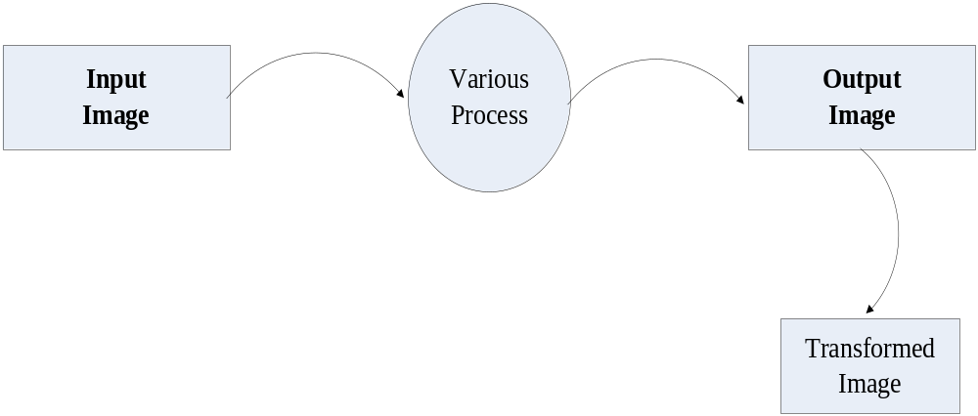

Menu Tree:
Project

Home
File

Main Menu
Edit

Transforms

Effects

Help
File Menu:

File
Open
Save
Exit

About Menu:

Help

About
About

Transform Menu:

Transform
Horizontal Mirror
Vertical
Stretch
Vertical
Mirror
Rotate
180 deg
Rotate
45 deg
Zoom In
Shear
Horizontal
Stretch
Zoom Out
Central Crop
250%
350%
400%
150%
300%
100%
50%
200%

Effects Menu:

Effects
Invert
EdgeDetect
RedEyeView
Brightness
GreenEyeView
Blur
BlueEyeView
GreyImage
Sharpen
Custom

Schema Diagram:

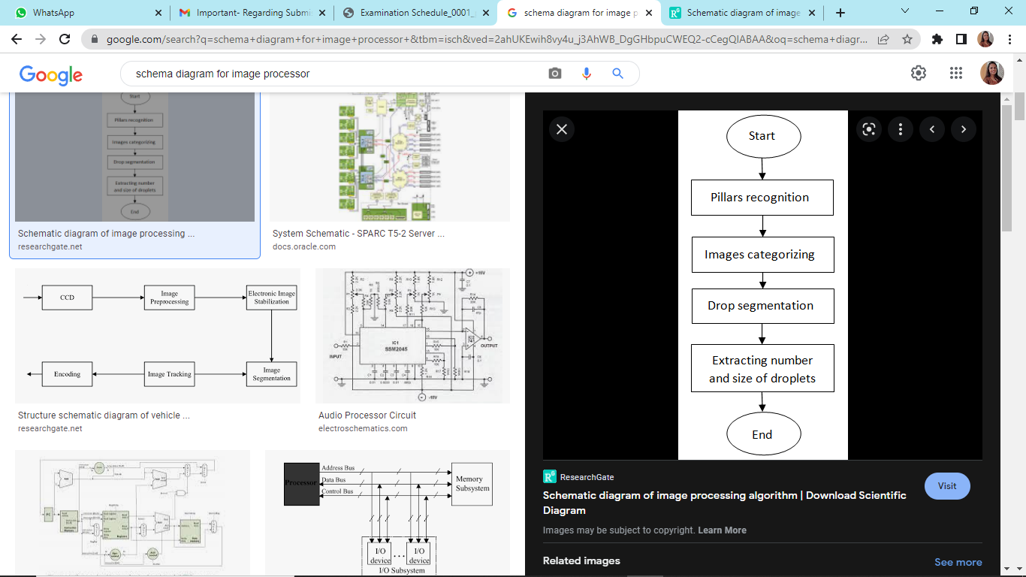
5.RESEARCH OUTCOME

Color Filter:

Color filters are sometimes classified according to their type of spectral absorption: short-wavelength pass, long-wavelength pass or band-pass; diffuse or sharp-cutting; monochromatic or conversion. The short-wavelength pass transmits all wavelengths up to the specified one and then absorbs. The long-wavelength pass is the opposite.

Convolution:

The trick of image filtering is that you have a 2D filter matrix, and the 2D image. Then, for every pixel of the image, take the sum of products. Each product is the color value of the current pixel or a neighbor of it, with the corresponding value of the filter matrix.

Blur:

The blur is a subclass of Convolve and simply runs through every pixel in the source image array, imgpixels, and computes the average of the 3x3 box surrounding it. The corresponding output pixel in newimgpixels is that average value.

Invert:

This filter will invert the alpha channel of an image. This is not normally terribly useful, but has its uses on accession. There are no parameters to this filter.

Grayscale:

Grayscale or grayscale digital image is an image in which the value of each pixel is a single sample, that is, it carries only intensity information. Images of this sort, also known as black-and-white, are composed exclusively of shades of gray, varying from black at the weakest intensity to white at the strongest.

RGB Scale:

The RGBScale is used to convert one image to another, pixel by pixel, transforming the colors along the way. This filter could be used to brighten an image, to increase its contrast, or even to convert it to grayscale.

Sharpen:

To sharpen the image is very similar to finding edges, add the original image, and the image after the edge detection to each other, and the result will be a new image where the edges are enhanced, making it look sharper.

Edge Detection:

This filter detects the edges in a filter. For each pixel, it looks a each channel, finds the local gradient and replaces the channel by a value determined by the gradient. Edges become white while flat areas become black.

Transform:

Transform attribute in the Graphics2D context to move, rotate, scale, and shear graphics primitives when they are rendered. The transform attribute is defined by an instance of the AffineTransform class. An affine transform is a transformation such as translate, rotate, scale, or shear in which parallel lines remain parallel even after being transformed.

Crop Image :

Crop Image filters an image source to extract a rectangular region .One situation in which this filter is valuable is where you want to use several small images from a single, larger source image .

Zoom:

The modified (zoomed image) should be the same size as the original image; in a zoomed image the specified portion of the original image now fills the entire image window.

Shear:

Shearing can be visualized by thinking of an image superimposed onto a flexible rubber sheet. If you hold the sides of the sheet and move them up and down in opposite directions, the image will undergo a spatial stretching known as shearing. The shear operation shears an image either horizontally or vertically

Rotate:

The rotate operation rotates an image about a given point by a given angle. Specified x and y values define the coordinate of the source image about which to rotate the image and a rotation angle in radians defines the angle of rotation about the rotation point.

Loading And Saving an image:

When you select either open or save menu from the file menu the corresponding dialogue box will appear. We can browse to the decide picture using this dialogue box. After selecting the picture we can insert that into our work area by double clicking the picture or clicking the open button in the dialogue box. In the save dialogue box browse to the folder where we want to save our file name it and click save button. Thus it will save in the corresponding folder.

6.PROPOSED TIME DURATION

BIBLIOGRAPHY

1] Theo Pavlidis, Algorithms for Graphics and Image Processing, Computer Science
Press, 1982.
[2] John C. Russ, the Image Processing Handbook, CRC Press, 1995.
[3] Ernest L. Hall, Computer Image Processing, Academic Press, 1979.
[4] David Bistry [et al.], Complete Guide to MMX Technology, McGraw-Hill 1997.
[5] Joe King, Matlab for Engineers – Second Edition, Addison-Wesley Publishing
Co., 1998.
[6] Barry Haynes, Photoshop 6 Artistry – Mastering the Digital Image, New Riders
Publishing, 2001.
[7] Lawrence H. Rodriguez, Building Imaging Applications with Java Technology,
Addison-Wesley Publishing Co., 2001.
[8] Michael J. Laslo, Object-Oriented Programming featuring Graphical Applications
In Java, Addison-Wesley Publishing Co., 2001.
[9] Mitchell Waite [et al.], Data Structures and Algorithms in Java, Waite Group
Press, 1999.
[10] Matthew Robinson [et al.], Swing, Manning
[11] Daniel M Hoffman, Software Design, Automated Testing and Maintenance,
International Thompson Computer Press, 1995.
[12] C. T. Arrington, Enterprise Java with UML, John Wiley and Sons, 2001.
[13]Image Processing in Java – Riyaz Mansoor
[14] www.intel.com
[15] www.microsoft.com
[16] www.imagemagick.org
[17] www.adobe.com
[18] Java.sun.com
[19] www.mathworks.com

